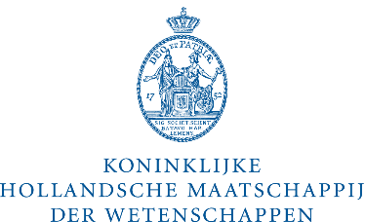
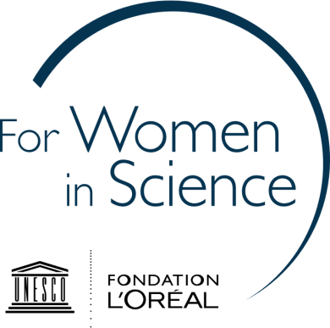

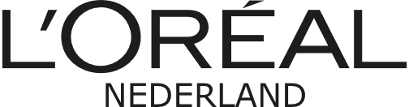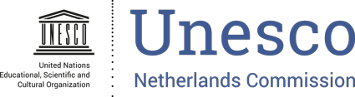

Application form
Dutch L’Oréal-Unesco Rising Talents Prize 2019
Please read the Rules and Regulations before completing this form.

Details of the applicant

Title(s)
First name
Surname
Place and date of birth
Nationality
Postal Address
Telephone
Mobile phone
E-mail
Personal website/social media accounts (if relevant)

Research position and experience

University/research centre
Faculty/Department
Current position
Discipline(s)/specialization
Master degree(s) – discipline and university/research institute
PhD degree(s) – if applicable; discipline and university/ research institute
Number of years post-Ph.D. academic experience
If applicable, list the total duration of maternal/ parental leaves taken
Proofs of excellence (scholarships, grants and awards obtained)

Research description

Please provide a short overview of your current research activities (max 2 pages) including:

- Introduction to the research topic
- Research aims
- Key research activities carried out
- Key aspects of innovation in relation to the state of scholarship in the field
- Relevance to society: potential for knowledge dissemination and application.

Submit your application

Your application should consist of the following:

- This application form, filled, including a description of your research activities;

- Your CV including a list of your key publications (4 pages max.);

- Two letters of recommendation by (international) specialists in your field;

The letters should make explicit reference to the candidate’s potential to maintain a high level of quality in her future career. Note that the jury will not accept letters from relatives or others that have a personal, non-work related relationship with the candidate that could lead to conflict of interest.

- Two of your most relevant publications, if available (in PDF).

